
DIGITAL ASSIGNMENT 3

Name: Soumyadeep Ganguly
Reg No: 24MDT0082
Course: Big Data Analytics Lab
Course Code: PMDS507P

Step 1: Preparing the Input Data
First, we need some data to process. A simple text file named introtohadoop.txt was created containing a single sentence about Hadoop. This file serves as the input for our MapReduce job.
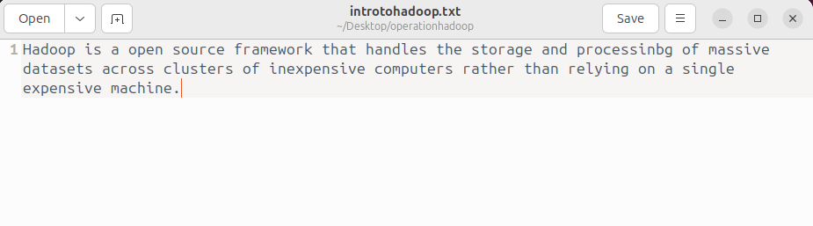File: introtohadoop.txt Content:
Step 2: Creating the Mapper Script
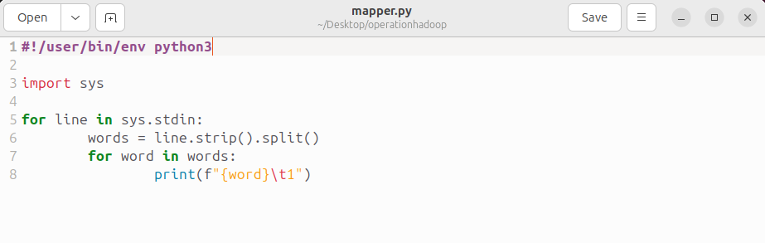The mapper is the first phase of the MapReduce job. Its role is to read the input data line by line, process it, and emit intermediate key-value pairs.

Step 3: Creating the Reducer Script
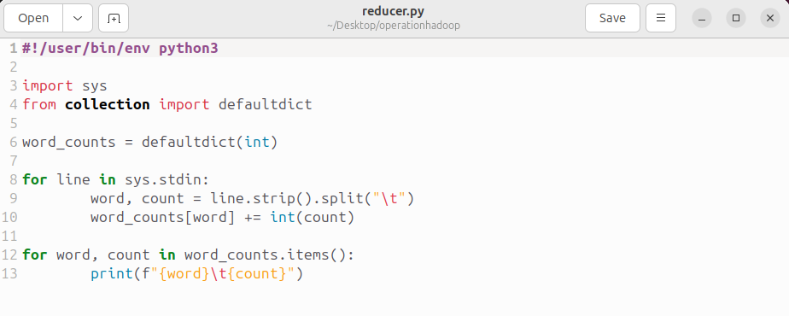The reducer receives the sorted output from the mapper. Its job is to aggregate the values for each unique key.
Step 4: Preparing the Hadoop Distributed File System (HDFS)
Hadoop operates on data stored within its own distributed file system, HDFS. Therefore, we must copy our local input file into HDFS.
- 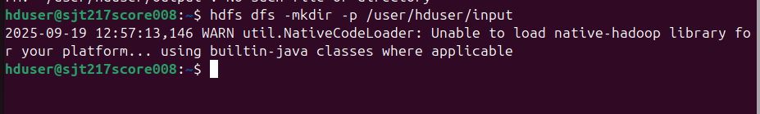Create an Input Directory: An input directory was created in HDFS to store our data file.
- 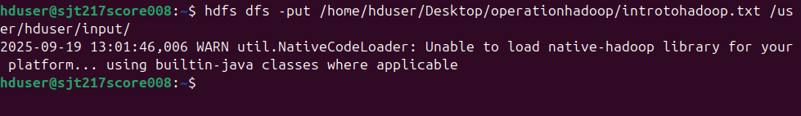Copy Data to HDFS: The introtohadoop.txt file was copied from the local filesystem to the newly created HDFS directory.

- 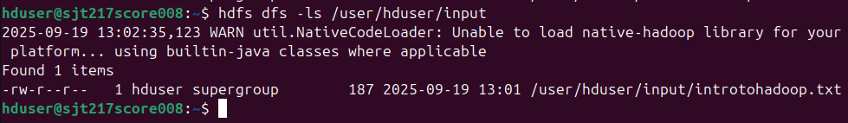Verify the File: We listed the contents of the HDFS directory and viewed the file's content to ensure it was uploaded correctly.

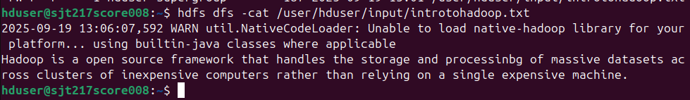

Step 5: Making Scripts Executable
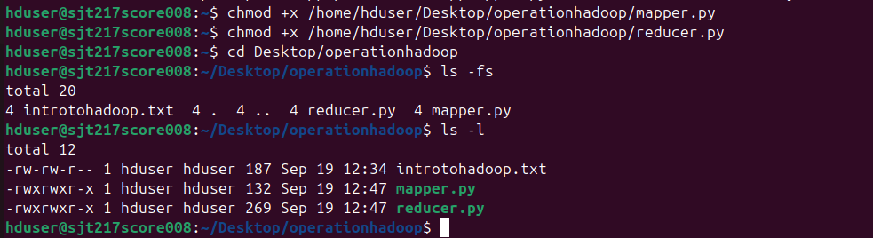For Hadoop Streaming to run our Python scripts, they must have execute permissions. The chmod +x command was used to grant these permissions.

Step 6: Running the Hadoop Streaming Job
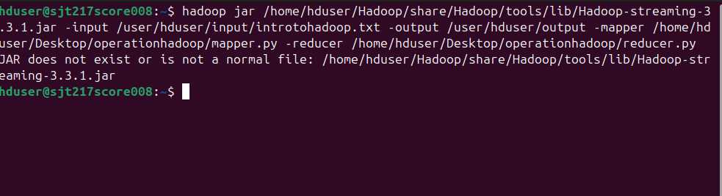With everything set up, the MapReduce job is launched using the hadoop-streaming JAR file. This command tells Hadoop where to find the input data, where to store the output, and which scripts to use for the mapper and reducer tasks.
Display the results:
